This is a semi-official guide on how to make “script mods” in Songs of Syx. In other words, how to inject java code into the code base. It's very simple to get started, however quite tricky to do something ambitious. The game is about a million of undocumented lines of codes, with rules and standards known only to the developer. My hope is that a knowledge base will be built up over time. I also currently plan to open source the game, making it possible for even more advanced mods.

Overview
The setup is simple. All you need to do is to add SongsOfSyx.jar into your projects classpath, and implement script.SCRIPT, then export this class as a jar, then add that to a mod folder. I'm going to show you how to do all this in eclipse, but if you're already technically savvy, you don't need to do it that way.

Eclipse IDE
I use eclipse to make the game. Eclipse is a code editor. It can be found here:
Eclipse Downloads | The Eclipse Foundation
If you prefer another editor, that's fine, but I'll cover how to set things up in eclipse.
TO make sure everything is setup after download and installation, try making a “hello world” program. You can follow this guide: How to create, build and run a Java Hello World program with Eclipse (codejava.net)

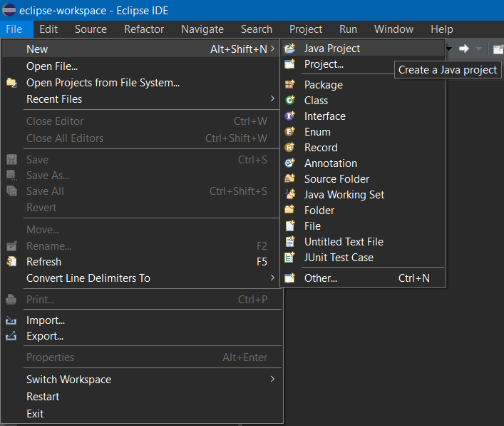
Project setup
Create a new workspace in eclipse, and create a new java project. Name it whatever you like.

Just keep everything as default, and hit “Finish”.

If you're prompted to create a module, then don't create one.
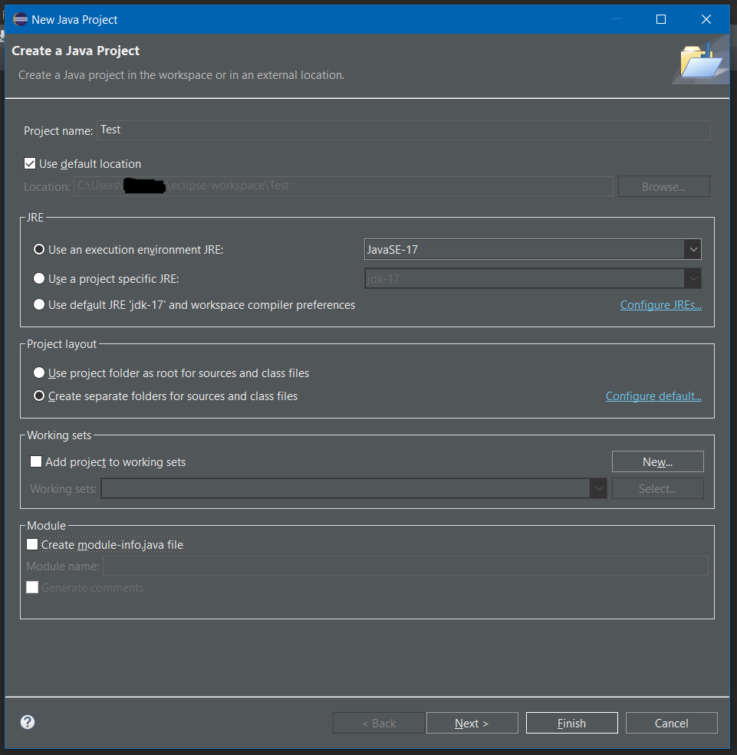

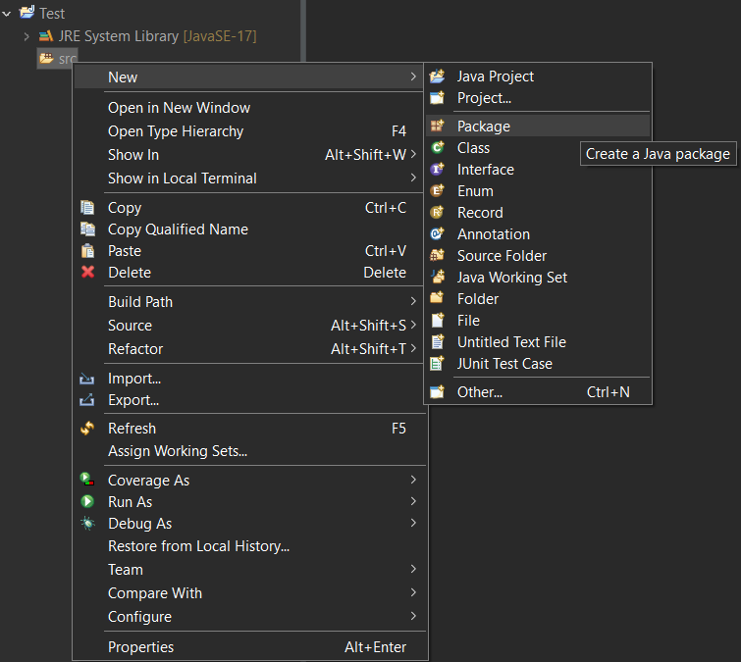
Now create a new package in your source module. You can name this something that identifies your mod, and it should be pretty unique.

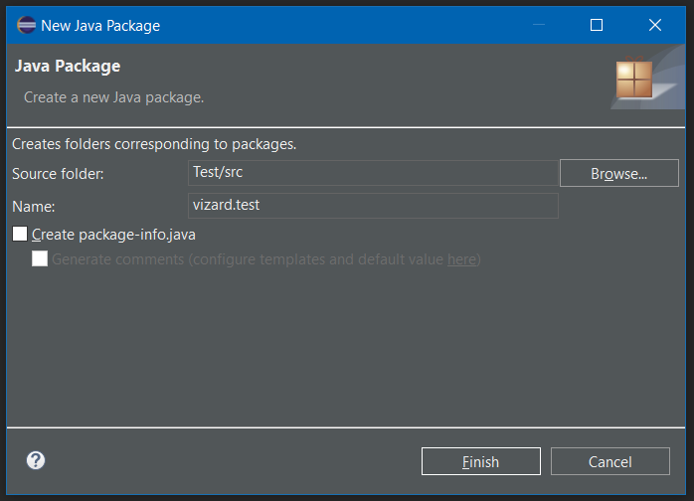
Yes, you use dots to separate words (subfolders) in java.

In the package, create a new class name it something Simple.
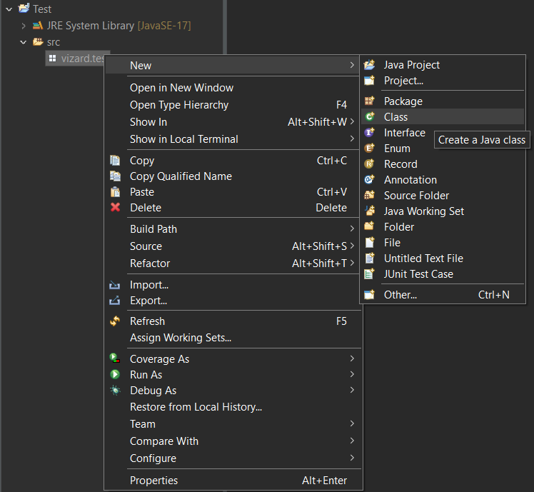
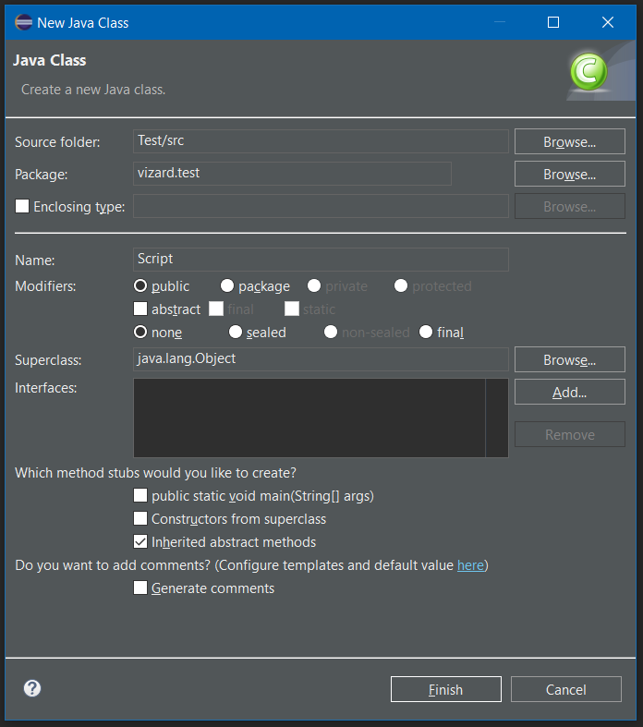

Now you must find your game installation, and the SongsOfSyx.jar file along with some folders..
Copy these and paste them into your project folder in eclipse.
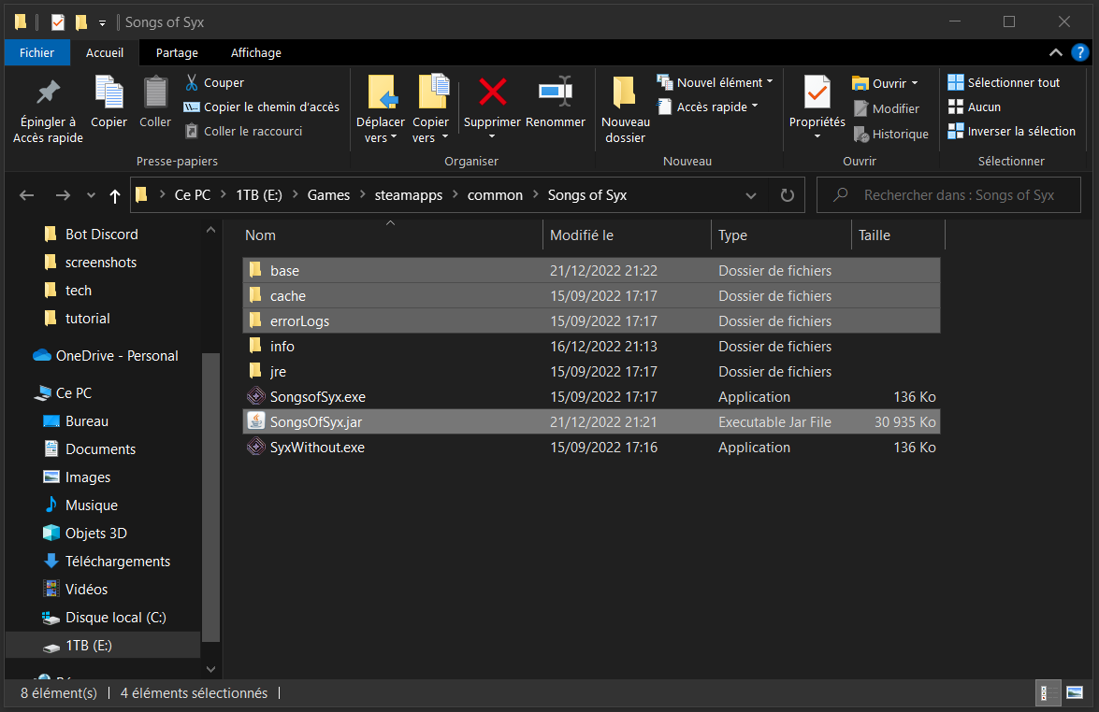
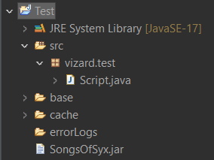

Now add SongOfsyx.jar to your build path.
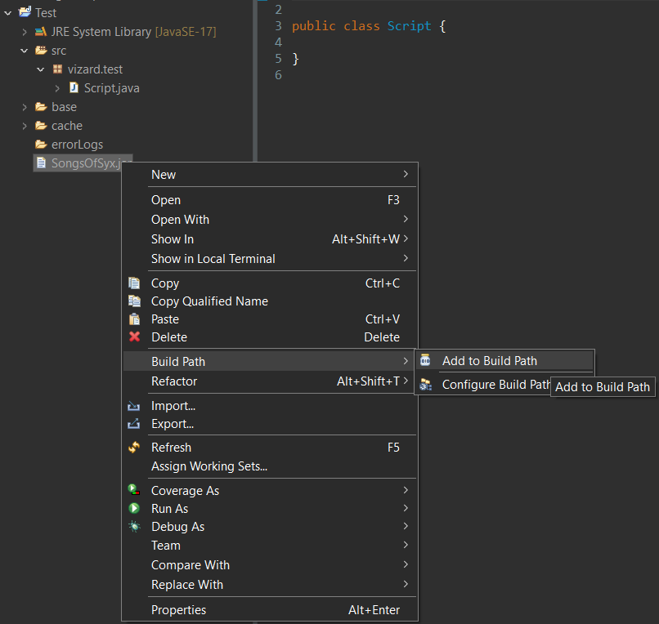

Back to your Script class. Append the following to the header in the editor:
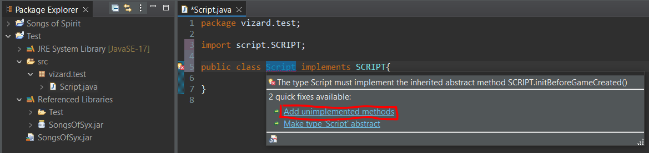
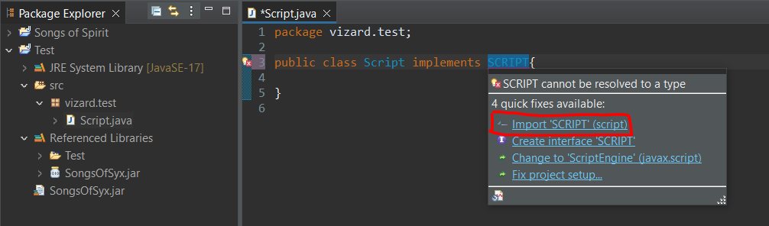

It should look like this when it's done:
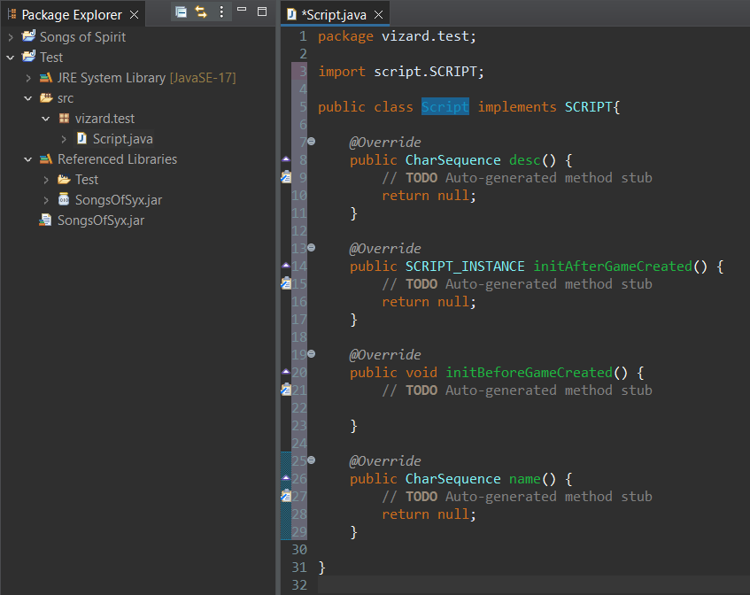

Now you need to implement the name and desc methods.
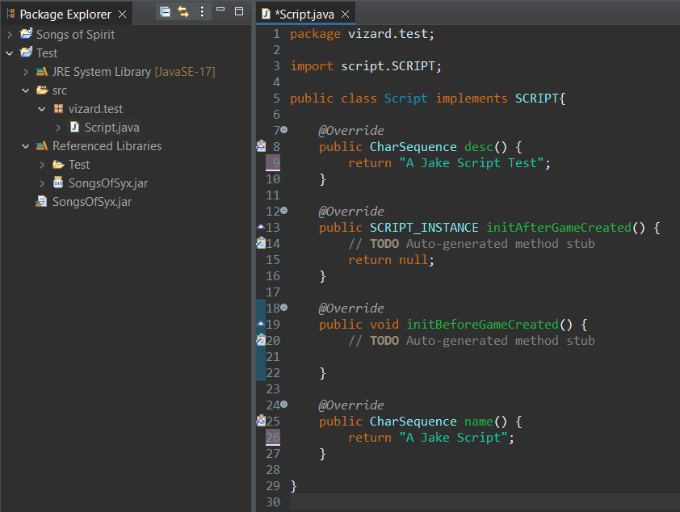

Now create a new class. Name it Instance !
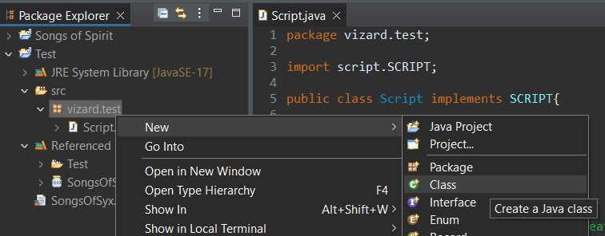

Have it, implement SCRIPT_INSTANCE.
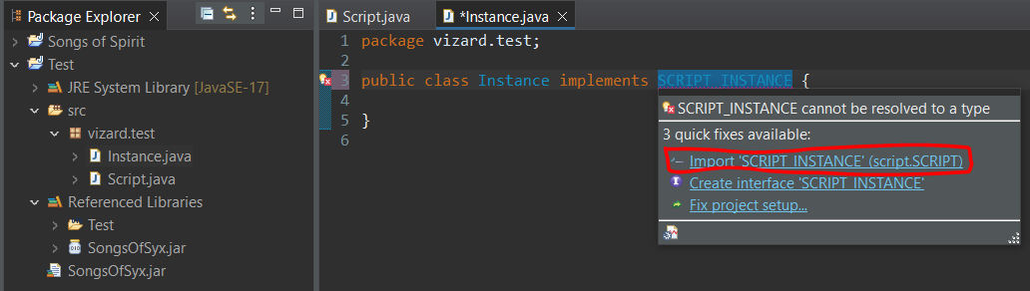
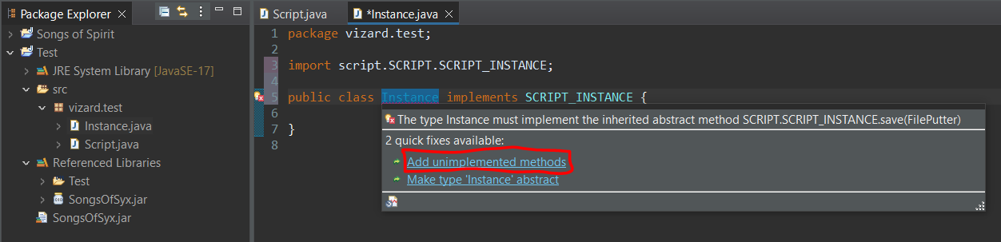
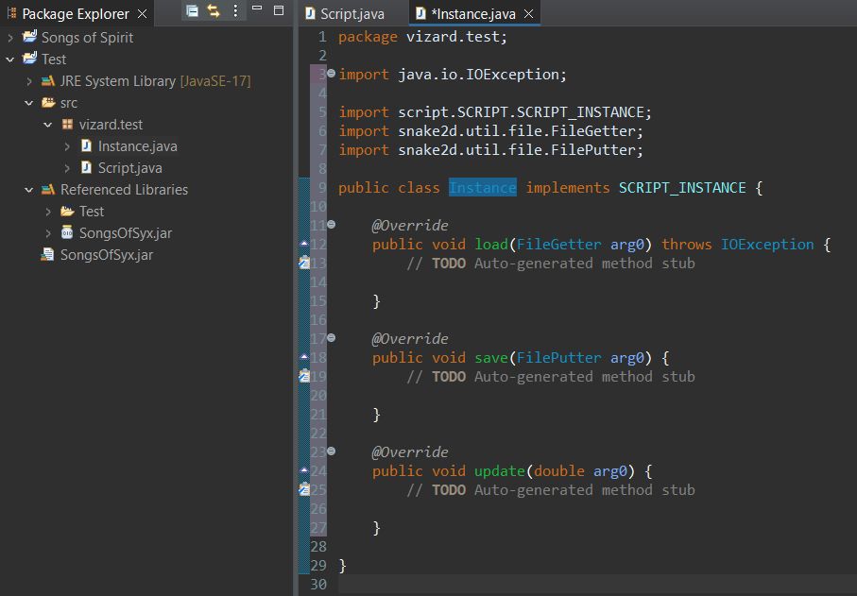

This is where you write your script. Usually in the update method. I'll just add something for proof of concept.
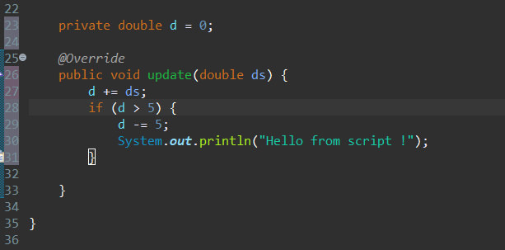

Now back to your other file. Return a new Instance here:
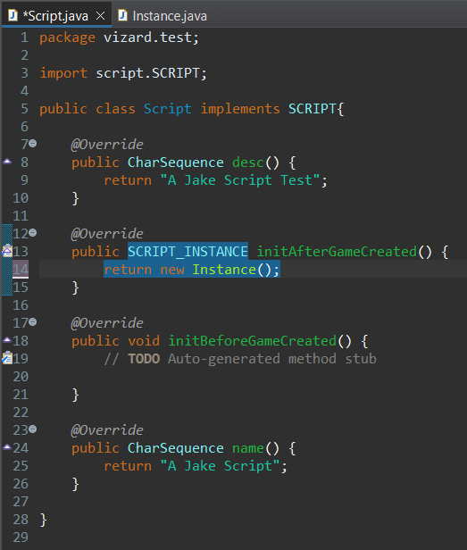
Our coding is done !

In your project you have “Referenced Libraries”. Expand it and run SongsofSyx.jar
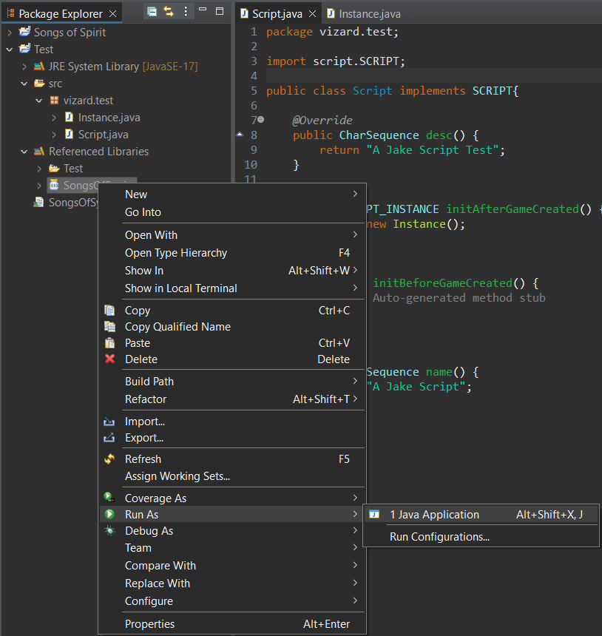

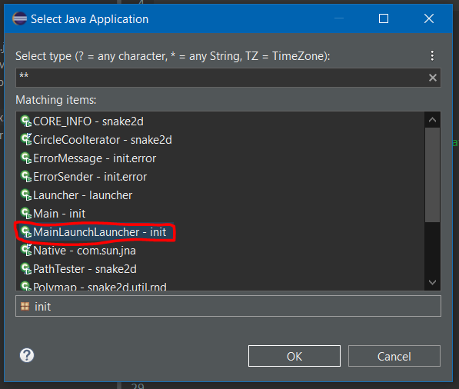
Select this one:

The SOS Launcher is launched, you can click on “INFO” to access the game mod folder.
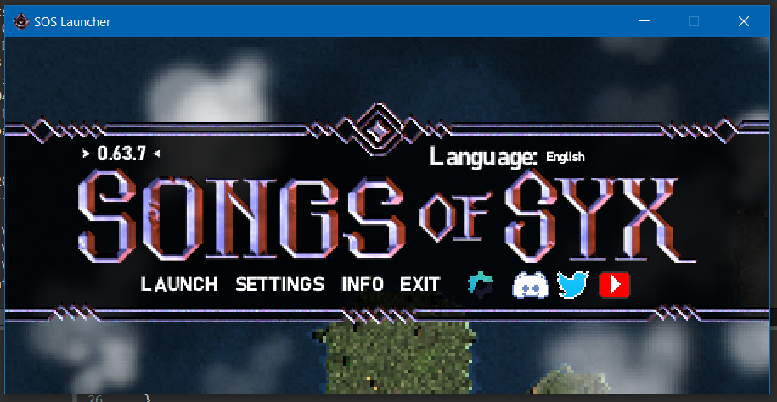

Head over to your mods:
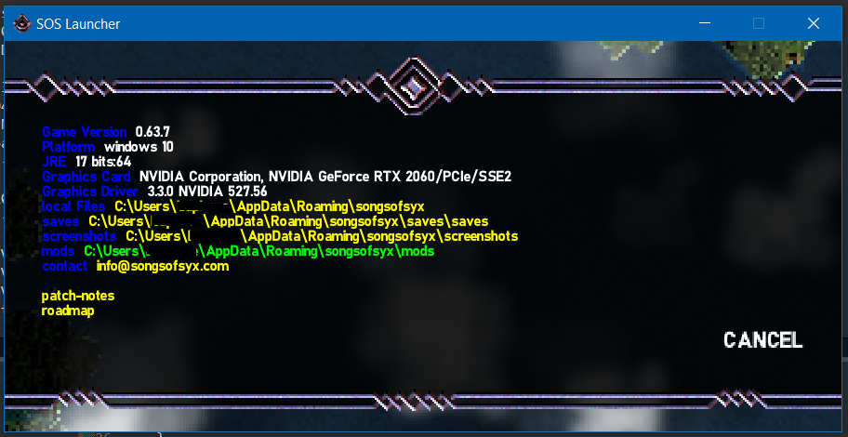
[Close the game after]

Create a new folder here:
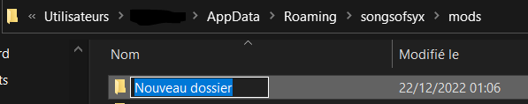

In the folder create an _Info.txt
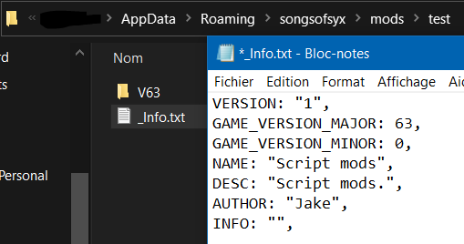
Add the following to the file:

VERSION: "1",
GAME_VERSION_MAJOR: 63,
GAME_VERSION_MINOR: 0,
NAME: "Script mods",
DESC: "Script mods.",
AUTHOR: "Jake",
INFO: "",

Change the strings to your liking. The GAME_VERSION_MAJOR should be the version targeted by the mod,

add a new folder. It should be named VXX where XX is the version of the game you're using.

[INFO: V = VERSION | XX = GAME_VERSION]
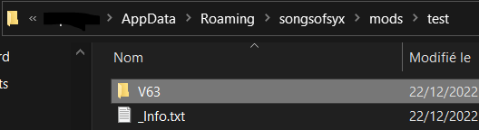

Inside that one, create a folder named script. And inside that one, create a folder named jar
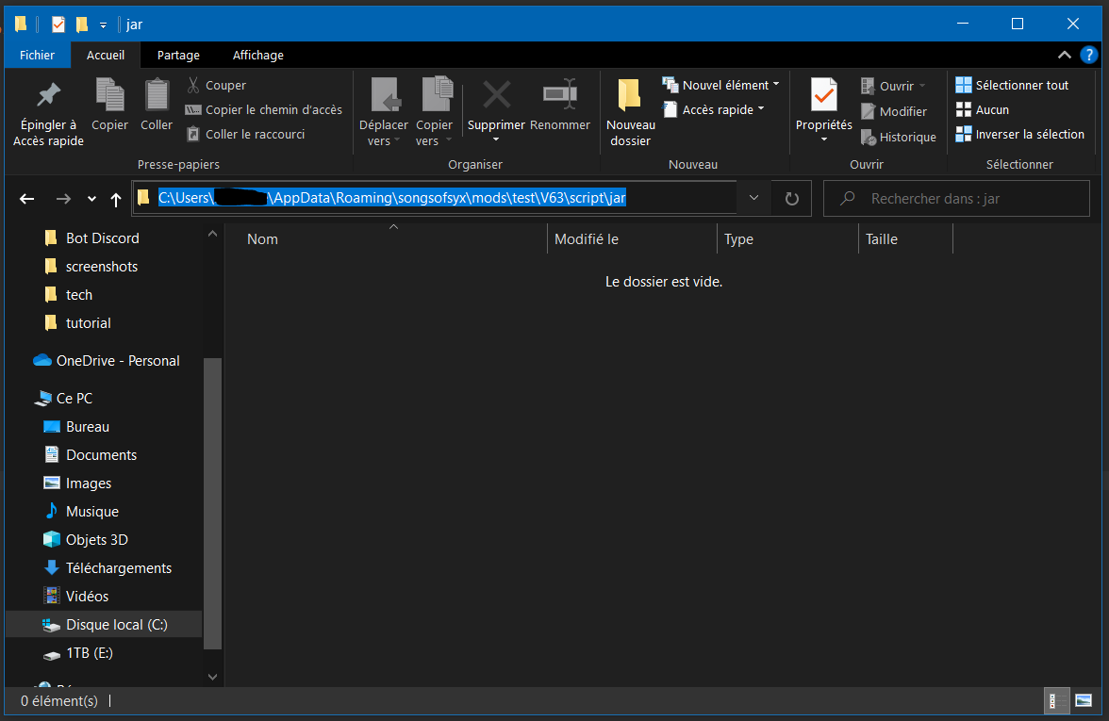
Copy this path.

Back to the workspace. Right click the src folder, then select “export”
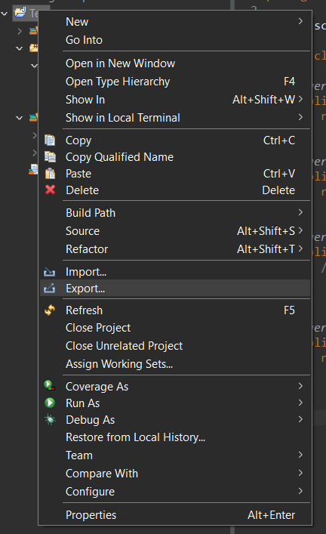

Pick this one: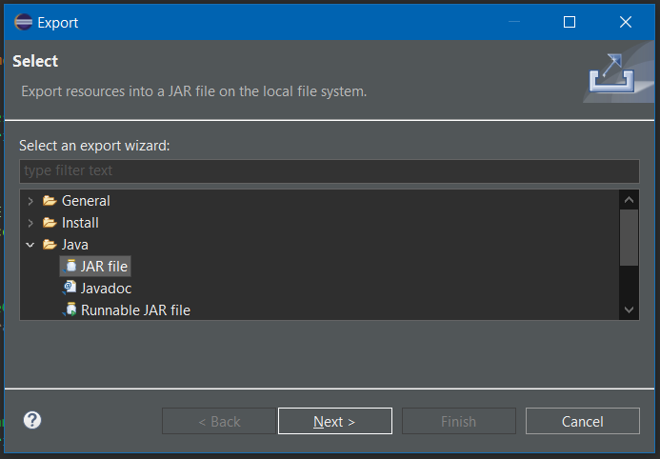

Browse…
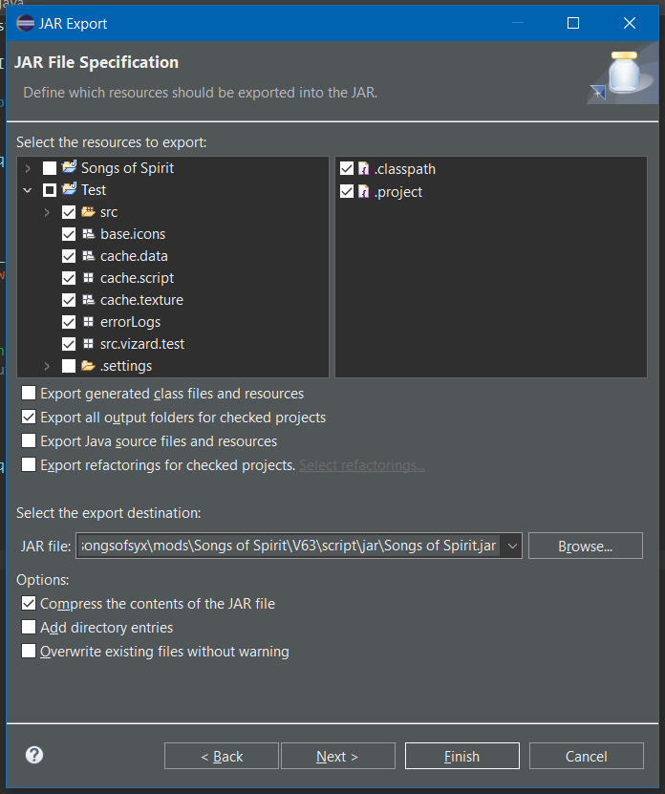

Find your newly created jar folder and export your project there.
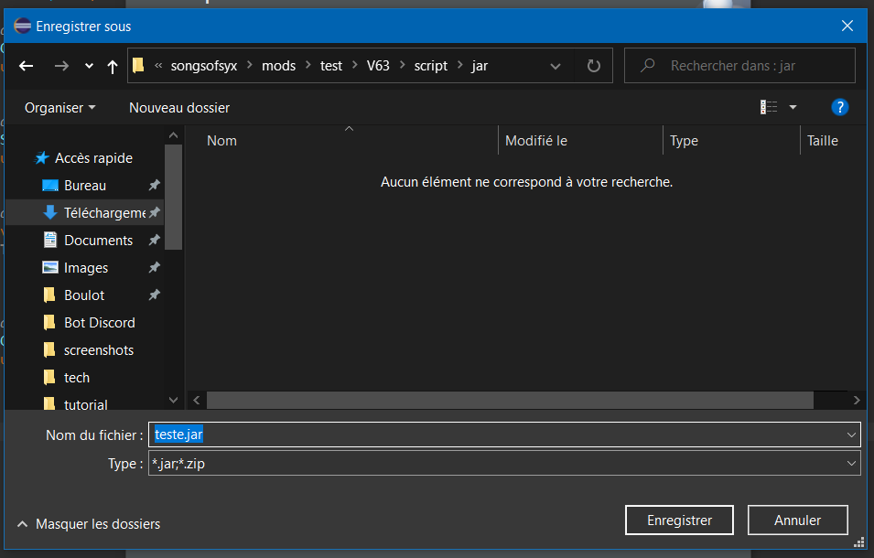
Name it something unique, similar to the name of your script.

Run the game again from eclipse.

Select your mod that should now show.
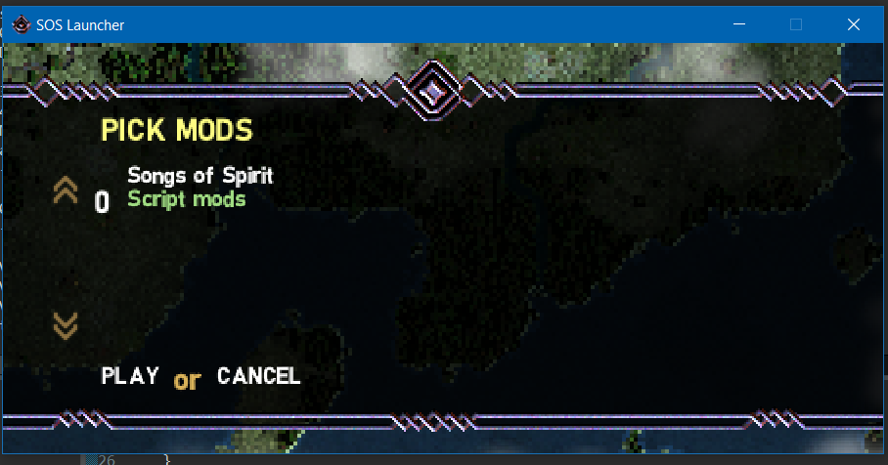

Select your script that should now be shown in the generate section.
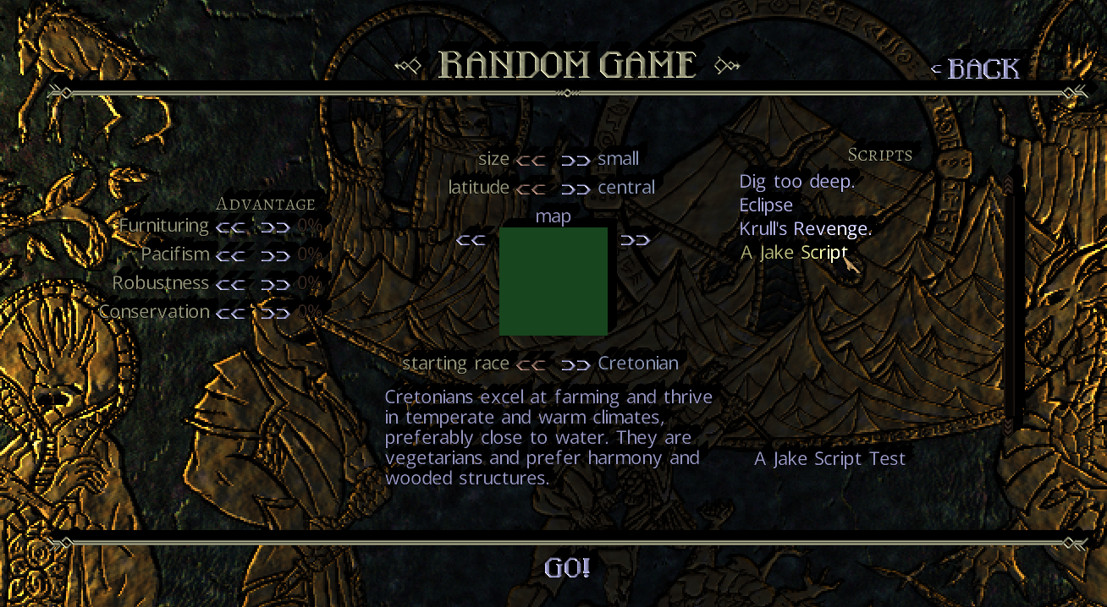

Our script is now running:
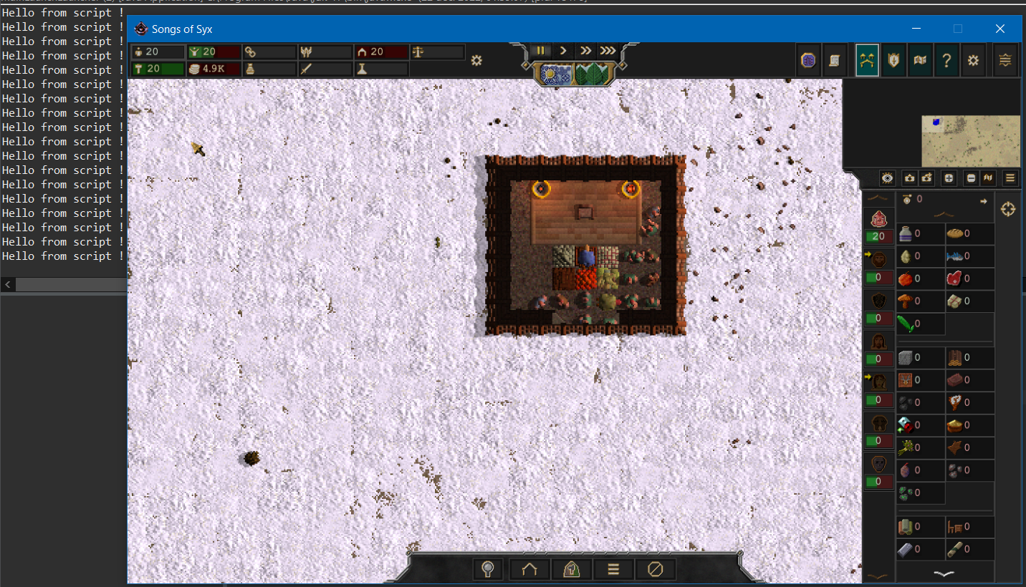

Don't forget to add your source to your mod, so others can learn, and use the source of the few scripts I've created.

And if you've made it this far, consider writing a better guide and send it my way.

